Reflection Questions

MODULE 1

Read: Ephesians 2:10

Reflection Questions:
- What has your understanding of ‘calling’ been up to now? How has this impacted your choices?

- What is the difference between ‘calling’ and ‘vocation’ in your mind?

- Do you feel pressure to make the right decisions all the time? Where does that come from?

- What does it mean to you to follow God above all else? How has God called you to him? How is God calling you to serve others?

- Did any of the panelists’ stories from the fall retreat resonate with you? In what ways? Which stood out the most and why?

- Take time to pray the following and take a few moments to listen to what God may be saying to you:

“God, what is it that you have designed me for? How can I serve your kingdom on earth? Where can I use my skills to make a difference?”
MODULE 2

Read: 1 Peter 2:9-12

Reflection Questions:
- How do you think the church should function?

- What does ministry mean to you?

- If we are to truly live for an ‘Audience of One,’ and allow God to guide every aspect of our lives, we must be willing to be set apart. Society expects us to live in a certain way, adhering to the societal norms of our time. Answering God’s call for our lives means living counterculturally from the world in which we live. We are to be set apart from others so that they may notice God’s goodness, kindness, mercy, grace, love, and redemption in every aspect of the lives of those who follow him. What does this look like for you?

- Take time to pray the following and take a few moments to listen to what God may be saying to you:

“God what does it look like for me to be set apart for you? How are you calling me to live right now with my current circumstances? Thank you for your goodness, kindness, mercy, grace, and love and give me a boldness to show it to others.”

MODULE 3

Read: Psalm 139:1-18

Reflection Questions:

- Your plans may not always go as imagined. How have you handled speedbumps, detours, and closed doors in the past?

- How would you like to handle them in the future? What practical steps can you take to make this happen?

- Can you think of an example of when something didn’t go the way you planned but it ended up turning out for the better?

- What about something that didn’t go to plan and turned out worse? How did you react in both circumstances? How did you move forward?

- Take time to pray the following and take a few moments to listen to what God may be saying to you:

“God begin to prepare me now for when my plans to go the way I was hoping they would go. Help me to hold my plans loosely in the coming days, months, years and help me to hear your guiding still small voice in all that I do.”

MODULE 4

Read: Proverbs 1:2-7

Reflection Questions:

- Think back on a time when you made an important decision. What was your process in your discernment? Are there additional factors you wished you had included?

- Talk to a trusted adult in your church (volunteer, deacon, pastor, etc) and ask them about how they make big decisions. What can you learn from them?

- Take time to pray the following and take a few moments to listen to what God may be saying to you:

“Holy Spirit bring to mind a trusted adult that I can talk to about how they make big decisions. I ask they begin to open my heart even now to what you want to teach me through that conversation. For any decisions coming up, big or small, remind me to seek wisdom that can only come from you.

MODULE 5

Read: Proverbs 15:22; 16:21; 1920

Reflection Questions:

For this module we want you to think of something that God may be inviting you into. This could be applying for a school, a career path, ministry opportunities, a change in habits, a new discipline/rhythm, a job, etc. Bring this invitation to your mentors attention and use the following questions with your mentor to help you discern possible next steps.

- When you think of our relationship over the years what would you say are my best skills.

- Can you think of a time in your life when you wrestled with an invitation from God to do something?

- After hearing my story about where I am wrestling with God’s invitation do you think this is what I should be wrestling with?

- If I said yes to this invitation what would be you concerns for me?

- If I said no to this opportunity what would be your concerns for me?

- Given all I’ve share with you what do you recommend I do?

- Would you pray about this and meet with me again to share what you hear God saying to you on this?

MODULE 6

Read: Psalm 139:1-18 [slowly read this passage. Highlight, write, or circle words that stand out to you from this passage]

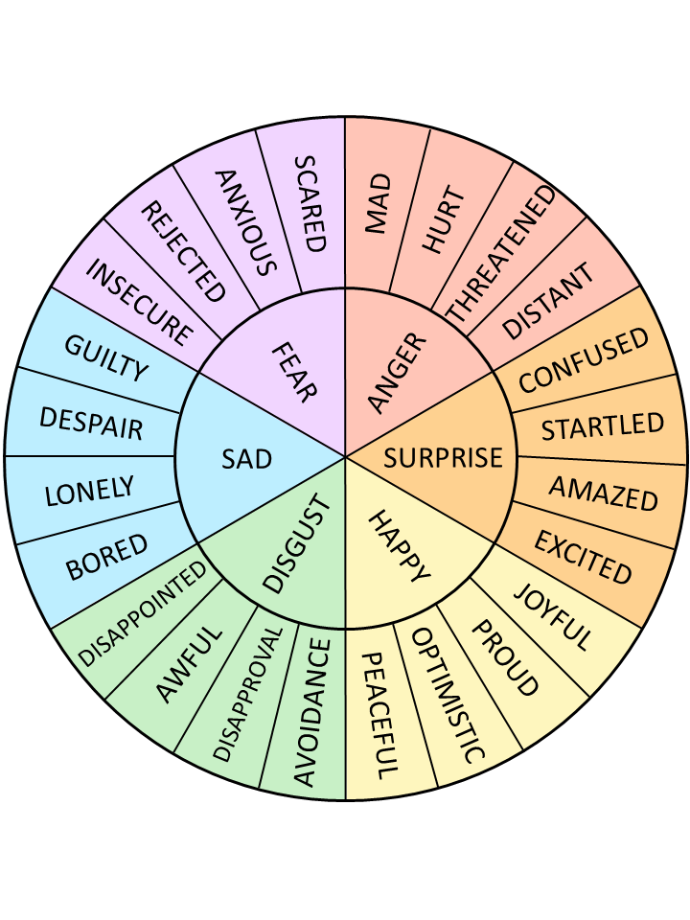
Reflection Questions:
- What words or phrases stood out to you in this passage?

- Look at the emotions wheel. How do the words or phrases you’ve listed above make you feel? (eg. Confident, Optimistic, loved, etc.)

- Look at the emotions wheel again. What are some of the emotions you feel about your future, or what you sense God may be inviting you into?

- How do the emotions you feel about your future compare with those that you felt after reading the passage from psalm 139? What does this tell you?

MODULE 7

Read: Ephesians 4:11-16, Romans 12:1-8

Reflection Questions:

1. Do the free online Spiritual Gifts test in the resource section of the module.

- What are your results from the spiritual gifts test?

- Are you surprised by your results from the spiritual gifts test? Do they resonate with you?

- Where do you see these spiritual gifts already playing out in your life and local context?

- Where do you see opportunity to grow in using your spiritual gifts?

2. Do the free online Strong Interests test in the resource section of the module.

3. Do the free online Passions Audit in the resource section of the module.

- What did you discover about your calling through the spiritual gifts test, interests audit, and passions audit exercises?’

- What might God be inviting you into?

- Does this have invitation have cross-over with your vocation?

MODULE 8

Read: Lamentations 3:16-33 [slowly read this passage. Highlight, write, or circle words that stand out to you from this passage]

Reflection Questions:

- Go back to the emotions wheel we’ve used in a past module. How do you feel when you think about failure?

- Is there a time when you ‘failed’ in your life? What about a time when what you thought was going to happen, didn’t happen? How did you handle it? Where was God in the middle of it? What do you now know on the other side of it, that you didn’t know then?

- When you fail, because it is inevitable at some point, what steps will you take to pick yourself back up and take steps forward?

- Take time to pray the following and take a few moments to listen to what God may be saying to you:

“Lord, teach me to look for you in the middle of hard times. May I lean into you when plans fall apart, when dreams disappear. May I look to you for the next steps, trusting that you will show up in the valley of darkness.”

